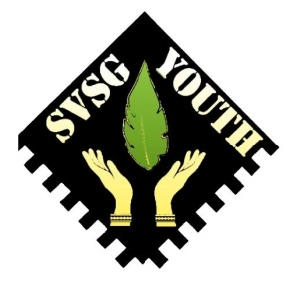
Samoa Victim Support Group - Youth
Youth Group Membership Registration Form
Please fill out this form to become a member of the Youth Group under the Samoa Victim Support Group Organization.

Personal Information
- Full Name:

- Date of Birth:

- Gender:
☐ Male
☐ Female
- Village:

- Phone Number:

- Email Address:

- Facebook page:

Emergency Contact Information
- Name of Emergency Contact:

- Relationship to Applicant:

- Emergency Contact Phone Number/Email:

Youth Group Involvement
- Why are you interested in joining the Samoa Victim Support Group Youth Group?
(Please write a brief response.)

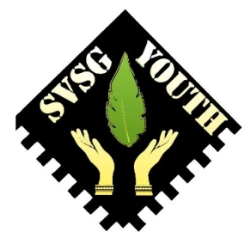
- What skills or talents would you like to contribute to the group?
(Please list any skills, hobbies, or experiences that could benefit the group.)

- What kind of activities or initiatives would you like to see the Youth Group engage in?

Health Information
- Do you have any allergies or health conditions we should be aware of?
☐ Yes
☐ No
If yes, please specify:

- Are you currently taking any medication?
☐ Yes
☐ No
If yes, please list:

- Agreement to Terms and Conditions:
By signing this form, I agree to abide by the rules and guidelines of the Samoa Victim Support Group Youth Group. I understand that active participation in the group involves a commitment to community service, leadership, and the promotion of safety and support for all members.

Signature of Applicant:

Date:

